**Juries**

1. Rena Netjes

Journalist

Netjes has been active as a freelance writer and journalist since 2002 . Media for which she writes or has written include de Volkskrant (in 2003), Elsevier (2005 - 2008), Knack (from 2007), Trouw (from 2010), NCRV (from 2011), Het Parool , BNR Nieuwsradio , NOS, The Correspondent , Zaman Today , Newsweek and The New York Times .

In 2014, Netjes was charged in Egypt with aiding the Muslim Brotherhood , which has been identified as a terrorist organization, and spreading false information. Neat was accused of engaging in such practices on behalf of Al Jazeera, even though it was not her principal. She was able to leave the country before she could be arrested. On 23 June 2014, she was sentenced in absentia to ten years in prison.

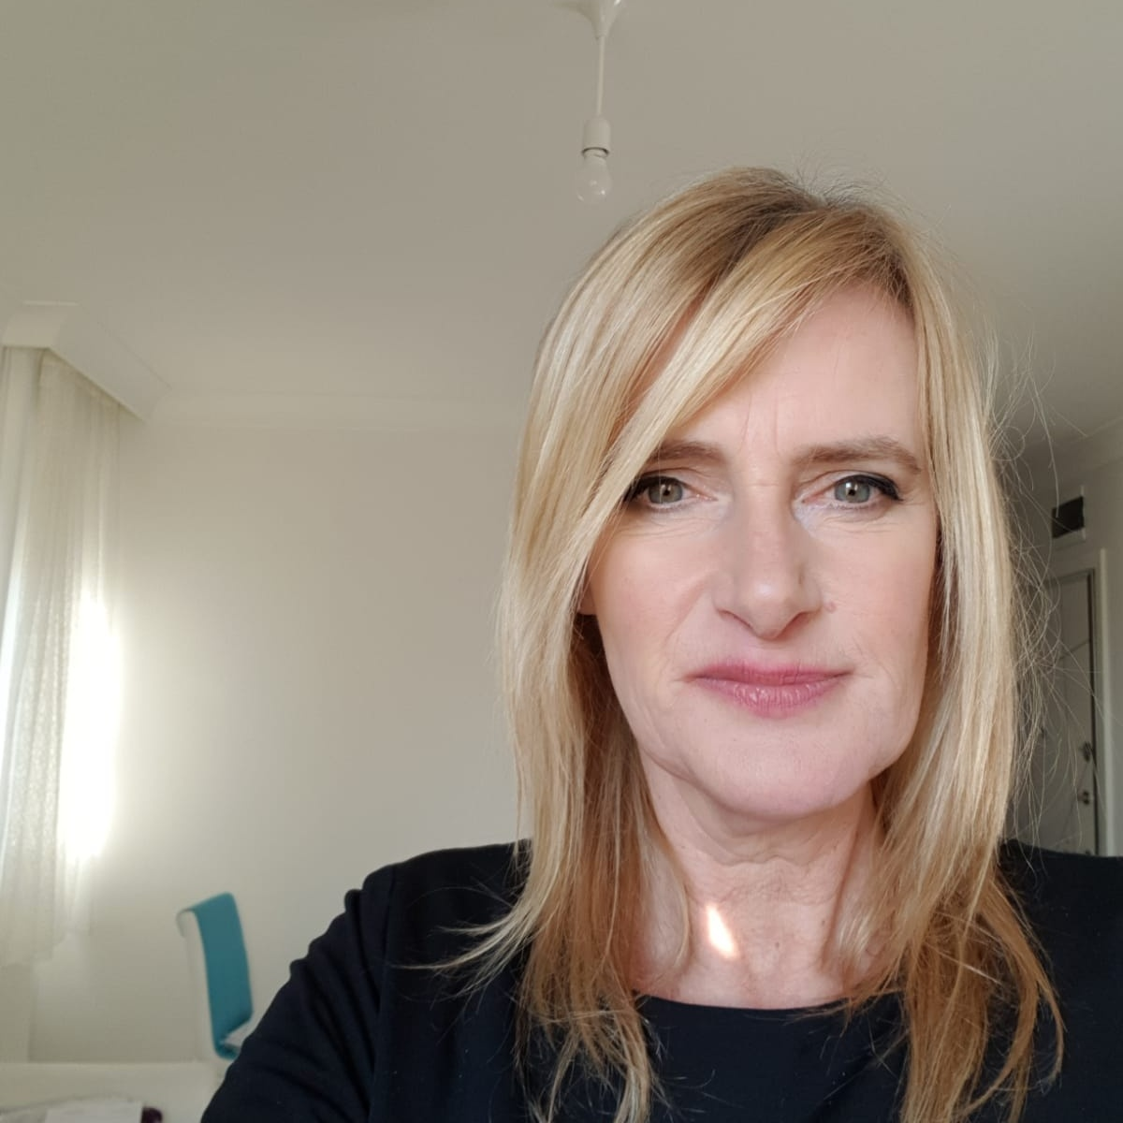

1. Asaad Taha

Journalist, producer & Documentary filmmaker

Asaad is an Egyptian filmmaker, worked as a journalist for "Alhaya", "AlAhram", "AlSharq Alawsat" and more newspapers and weekly magazine. He also worked with TV channels such as "MBC", "AlJazeera" & "AlAraby TV".

He Produced 25 documentary series, around 900 hours of documentaries which covered more than 80 countries around the world.

He interviewed presidents, rebels and kings; like "Ali Ezzat Begovic" & "the Dalai Lama".

* Awards:
* Best Documentary Program at Cairo Film Festival, 1997.
* Best Documentary at Kazan International Film Festival 2006 for making "El dorado".
* Best Documentary at Kazan International Film Festival 2007 for the Film "Seven Tents".
* Honored at the 2010 MIP Cannes Festival.
* Honored at East Europe Documentary Film Festival in Asilah, Morocco in 2014.

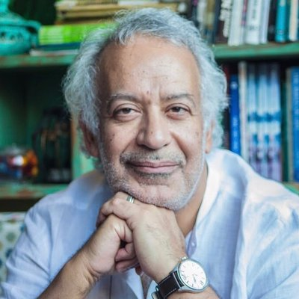

1. Madeleine Leroyer

Documentary filmmaker

Madeleine is a French documentary filmmaker. Her debut film #387 premiered at IDFA 2019 and received several festival awards.

* Awards:
* 2nd prize at the GMFF 2019 for the documentary #387.
* Prix de la Clairière at FIFDH 2020 for the documentary #387.
* Best Documentary Award at FIFF2020 for the documentary #387.
* #387 Film will be shown on TV in over 15 countries.

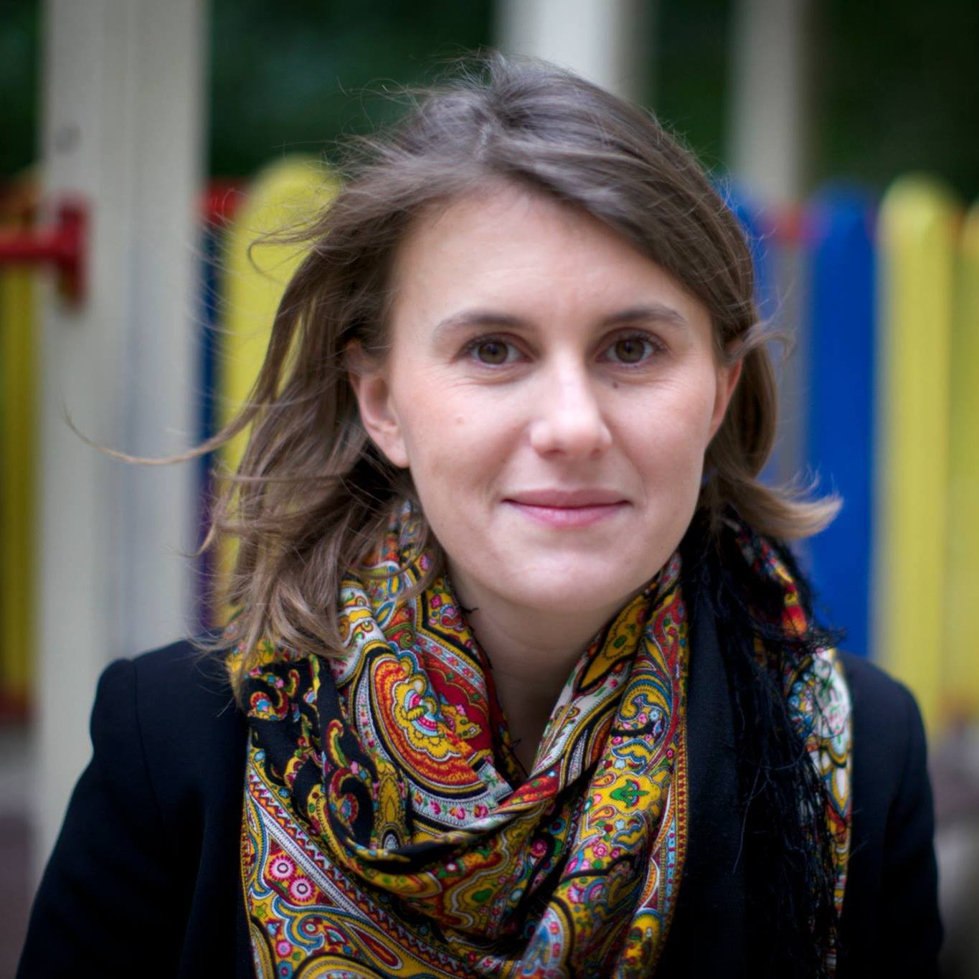

1. Wagdy El Araby

Filmmaker

Wagdy is an Egyptian filmmaker. He is born in 1950 and his first big role in cinema was 1960, since then he made more than 110 film and series. He participated in 3 films which were chosen from the best 100 film in the Egyptian cinematic history.   
He is now living in Turkey as he is also a political activist and he was exiled by the Egyptian regime. He is now presenting a TV show called “in the exile” on al Watan TV chnannel.

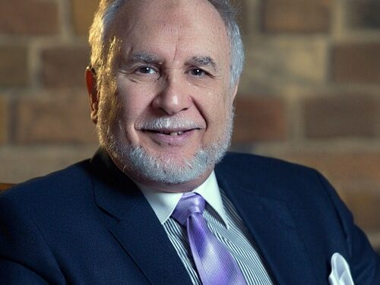

1. Teun Castelein

Artist and art teacher

Teun Castelein is an artist known for a wide range of entrepreneurial adventures.. With his projects he researches and questions the functioning of the free market and the chances of survival for the artistic and humanistic. For years he is actively teaching at BA and MA level in The Netherlands and abroad. His work is widely covered by national and international media. His shipping company ‘Lampedusa' received a Peace Pigeon at International Peace Day 2017. Castelein was nominated 'citizen of the year 2016' by the municipality of Amsterdam.

